19.HOME SERVICES SYSTEM

SEQUENCE DIAGRAM

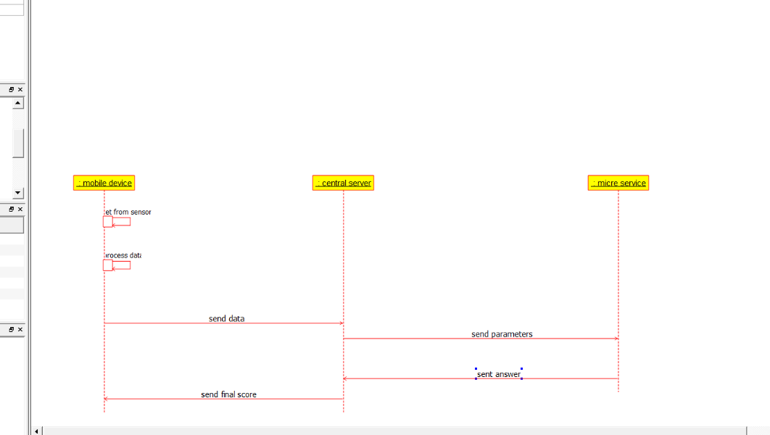

DEPLOYMENT DIAGRAM

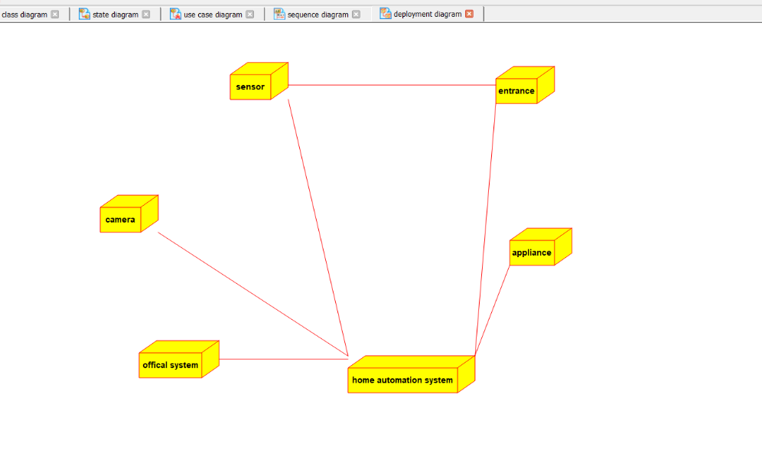

STATE CHART DIAGRAM

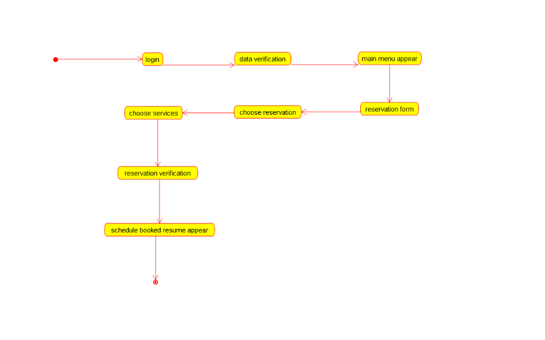

USECASE DIAGRAM

